Graphical abstract

Insert the GA here. This image

The image must have the following dimensions: 8 cm wide and 4 cm high. The image must also have a minimum resolution of 900 dpi. To ensure the quality of the image, accepted formats are tiff or png.
The graphic abstract should present the reader with a diagrammatic representation of the research described in the article. Thus enabling readers to easily identify the main message of the work. The graphic summary should not contain excessive details and information and is not intended to summarize the results.
The graphic abstract image file must also be included in the submission system.

Graphical abstract
(8 cm x 4 cm)

Text for the graphical abstract:
Insert here 1 to 3 lines of descriptive text about the graphical abstract.

Title of Your Manuscript Here

Authors Name: Due to the double-blind review process, do not include authors' names as well as affiliation information in the manuscript. Once accepted, this information will be included in the final version.
Check that the authors' full names and affiliations are correctly informed in the submission system

Abstract
Insert the abstract here as a single column. Abstracts should be up to 200 words long.
Keywords
Four to six keywords (separated by commas)

Introduction

All articles should begin with an Introduction, following Experimental Section, Results, Conclusion, and finally, Acknowledgements, References.
For these sections, write double-column and use Times New Roman 10, and line spacing 1.15.
The introduction should present the central theme of the proposed manuscript, justifying the interest based on current literature. In this section, the objectives of the article must be presented clearly and concisely. The introduction must contain state-of-the-art.
It is very IMPORTANT to remember that Scientia cum Industria has a blind review process. Therefore, DO NOT include in the text content that identifies the authors, such as names of laboratories or self-citations similar to “In our last work [1],...” or to “...presented in this work is a continuation than proposed in [1]”.

1.1. References and bibliography
In order to enable fast layout preparation, please respect the following rules:
Use the following reference format in the text: [1, 2, 5-8]. Use the following style for references in the bibliography section:

Experimental Section

Include here the essential experimental procedures/data.

Results
This section should present all the results and discussions obtained by using the experimental and theoretical methods used in work.

  - Tables
All Tables must be included in the manuscript as editable tables and not as a picture.
All Tables must be cited in the main text and ordered according to their citation in the main text. Table number (i.e., Table 1) and descriptive title are required for all tables.
An additional explanation must be included in the table footnotes.
Add the units in the header of the table (INSTEAD OF inside the table or the caption).
Acronyms/abbreviations/Greek symbols, etc., should be specified in the footnote, even if they have been specified in the text.

Table 1. Table caption.ª (Note: Please do not include the table in a textbox or frame)
Head 1^{b} | Head 2 | Head 3 | Head 4
Column 1 | Column 2 | Column 3 | Column 4
Column 1^{b} | Column 2 | Column 3 | Column 4
ª Table Footnote. ^{b} …

1.2. Figures
All Figures must be cited in the main text and ordered according to their citation in the main text.
Make sure that all texts and numbers shown in the graphs, charts, and diagrams are readable.
Figure number (i.e. Figure 1) and descriptive title are required for all Figures.
Multi-part figures (i.e. comparing Chart A and Chart B) must be submitted in one file and arranged as they are to be published.
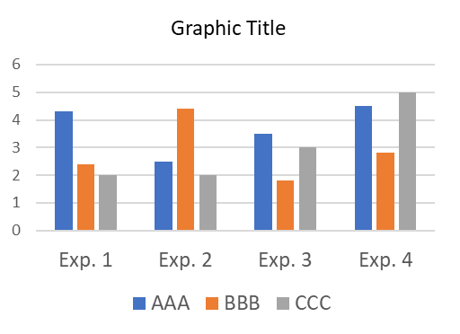Figure 1. Figure description.

Scientia cum Industria is an open-access journal. In order to avoid conflicts of interest with other publishers, please do not reproduce figures from other publications.
Please adjust the dimensions of the graphics to either one- or two-column representation. For one-column figures, the width should be 8.6 cm maximum, with 600 dpi minimum resolution. Two-column images should be 17.0 cm in width, with 600 dpi resolution.
The maximum total number of figures and schemes together should not exceed 6.

Instructions on how to include a double-column width figure, scheme, or table:
- Place the insertion point where you want to change the number of columns.
- On the Layout tab, click Breaks in the Page Setup group and select Continuous.
- Ensure the insertion point is in the new section, and on the Layout tab, in the Page Setup group, click Columns and select One.
- A figure, scheme, or table inserted into this section will now span two columns.
- Finally, add another section break after the figure, scheme, or table and change it back to two columns.

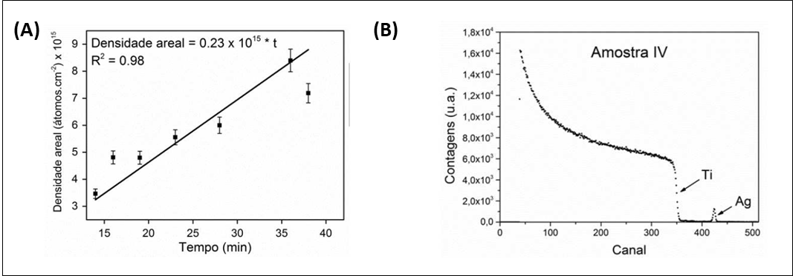
Figure 2. Figure description.

Conclusion
Conclusions should be concise and represent the most important aspects found during the development of the reported work. It should try to point out the scientific, technological, or theoretical advances made.

Acknowledgments
Use this section to acknowledge financing institutions and any contributions not in the nature of authorship.

References

The authors are responsible for the accuracy and completeness of all references.
- The reference list must be ordered as they appear in the text,
- List all authors and do not use “et al.”,
- Provide the DOI number always possible.

[1] (Example for journals) A. R. da Rosa, V. Villas-Boas, Adequacy Study on a Regional Airport to Achieve Energy Efficiency in a Renewable Way. Scientia cum Industria, vol 5, pp. 21-31, 2016. DOI:10.18226/23185279.v4iss1p21
[2] (Example for books) I. Sachs, Caminhos para o desenvolvimento sustentável. 4. ed. Rio de Janeiro: Garamond, 2002.
[3] (Example for book chapters) D. C. Martins, Y. P. Godoi, e N. Mascarenhas, Educação em astronomia: experiências e contribuições para a prática pedagógica. Em ensino de astronomia no ensino fundamental por meio da informatica. Átomo, Campinas, pp. 117–141, 2010.
[4] (Example for thesis) F. G. Echeverrigaray, Estudo da ação antimicrobiana pela modificação de regiões próximas a superfécie de aço inoxidável, M.S. thesis, Universidade de Caxias do Sul-PGMAT, Caxias do Sul, 2014.

Only For review articles
For Review articles, it should include the authors' biography photograph and the biography text as following.
Dimensions of the photographs: 3 cm wide and 2.5 cm high.
Delete this section if it is a non-review article.

Author 1 Full Name:
Author 1 Biography 1: 200 words maximum.

